Step3: Select “Add SVN Repository” and enter the URL of the repository as**file:///C:\SVN\Mandatory**.  
The repository gets added to the SVN Repositories

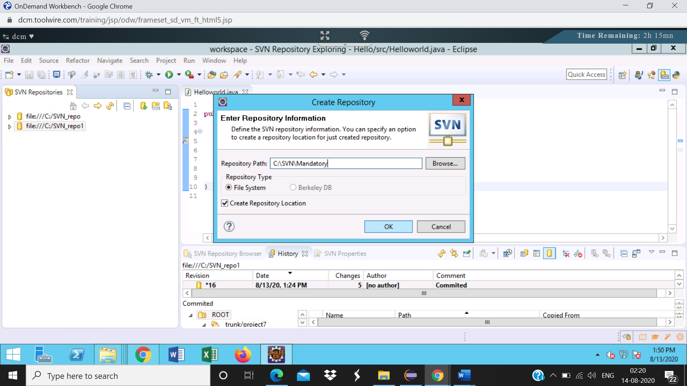

Repo gets added

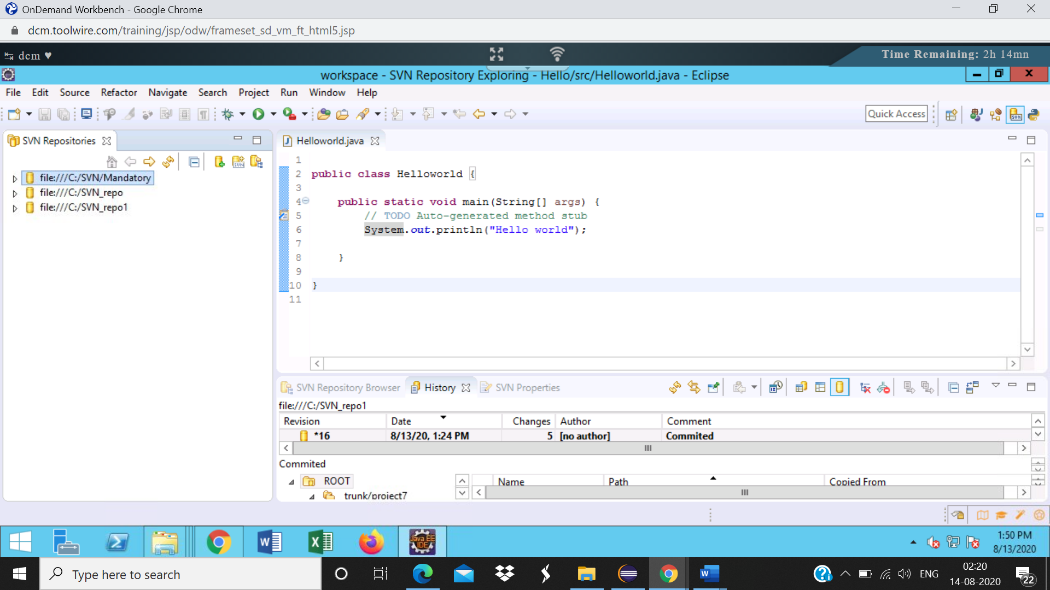

Step4: Right click on the **project10** inside trunk and select Checkout

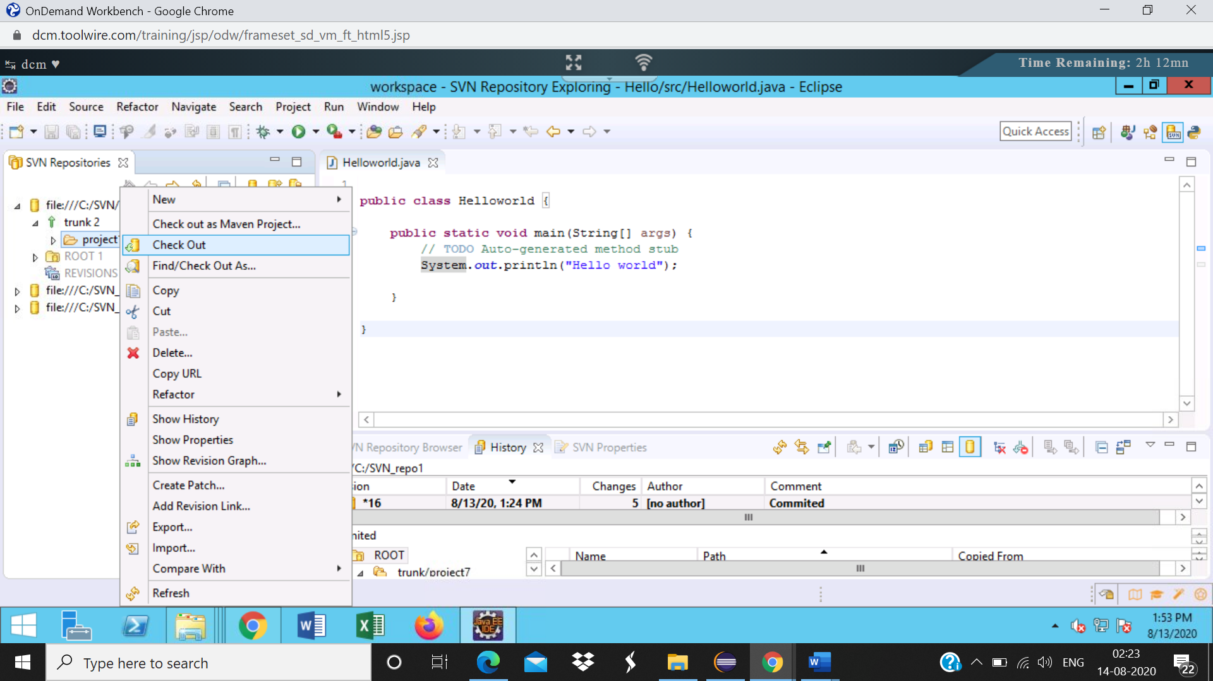

Step5:

Select “Check out as a project in the workspace” and specify the project name in the Checkout from SVN dialog.  
Click on Finish  
The project will be checked out to the workspace.  
Project name: Shipment_user1

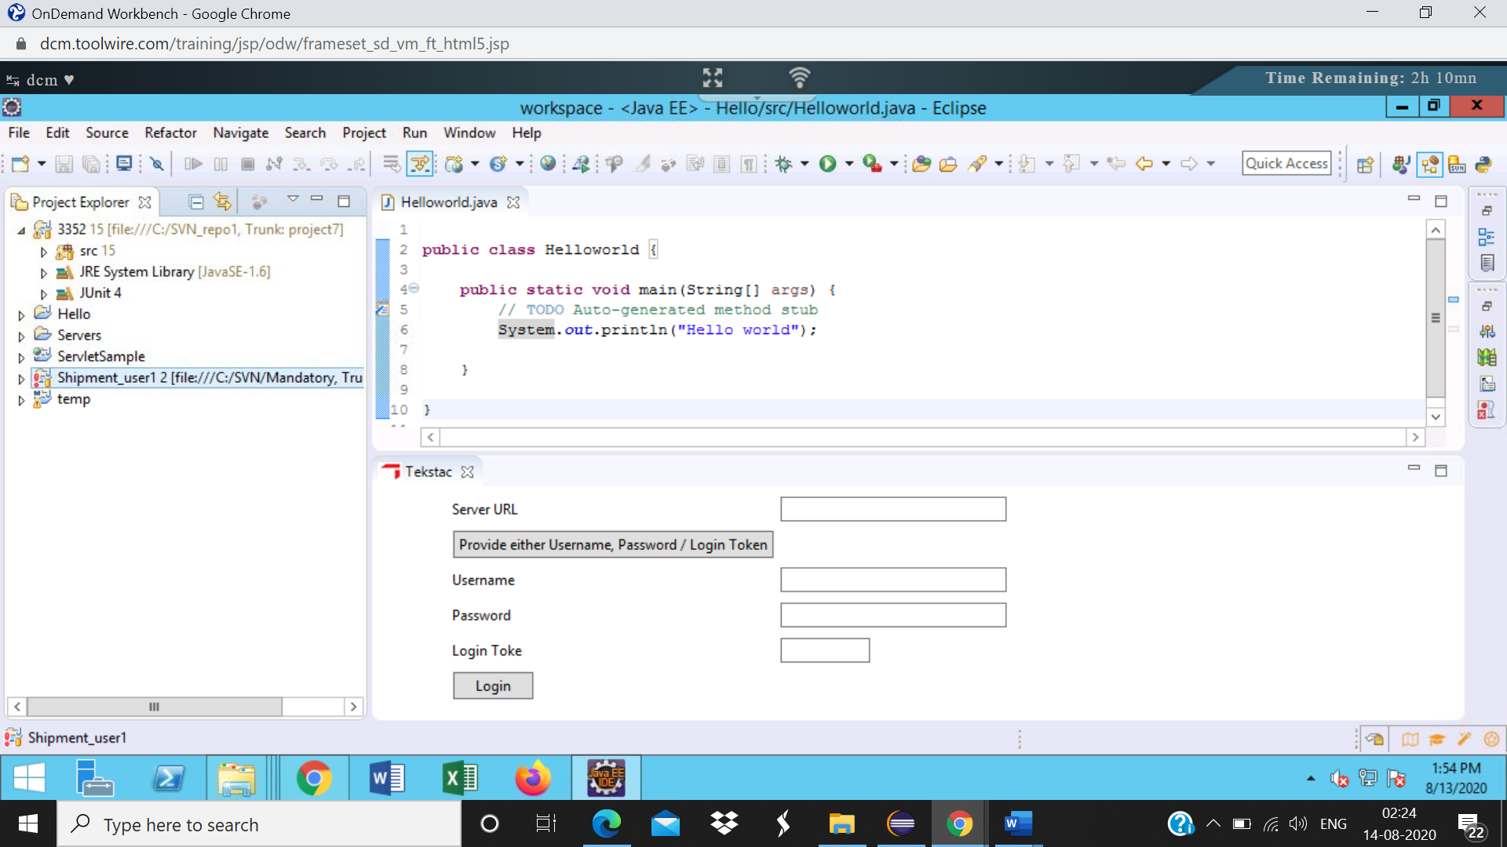

Step6:

|  |  |
| --- | --- |
| In the SVN Repository, check out the same project again with a different name. Project name: Shipment_user2 |  |

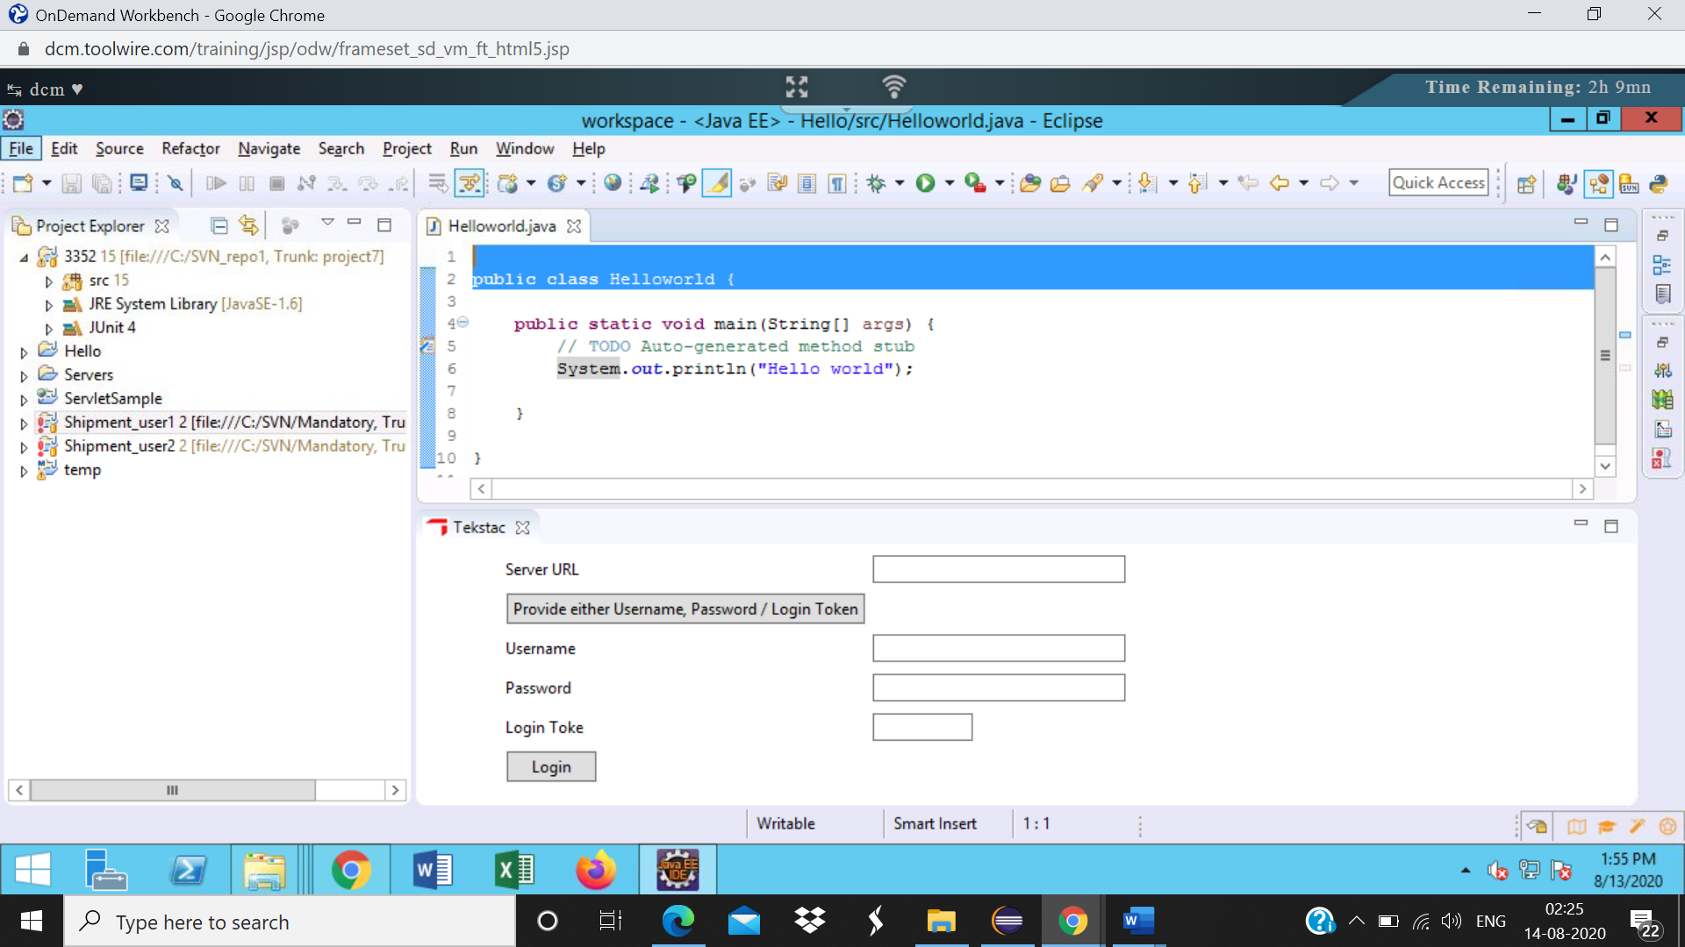

Step7:

|  |  |
| --- | --- |
| In Shipment_user1 project, Modify the ShipmentStatus.java file, Update the variable name from id to shipmentID and save the file |  |

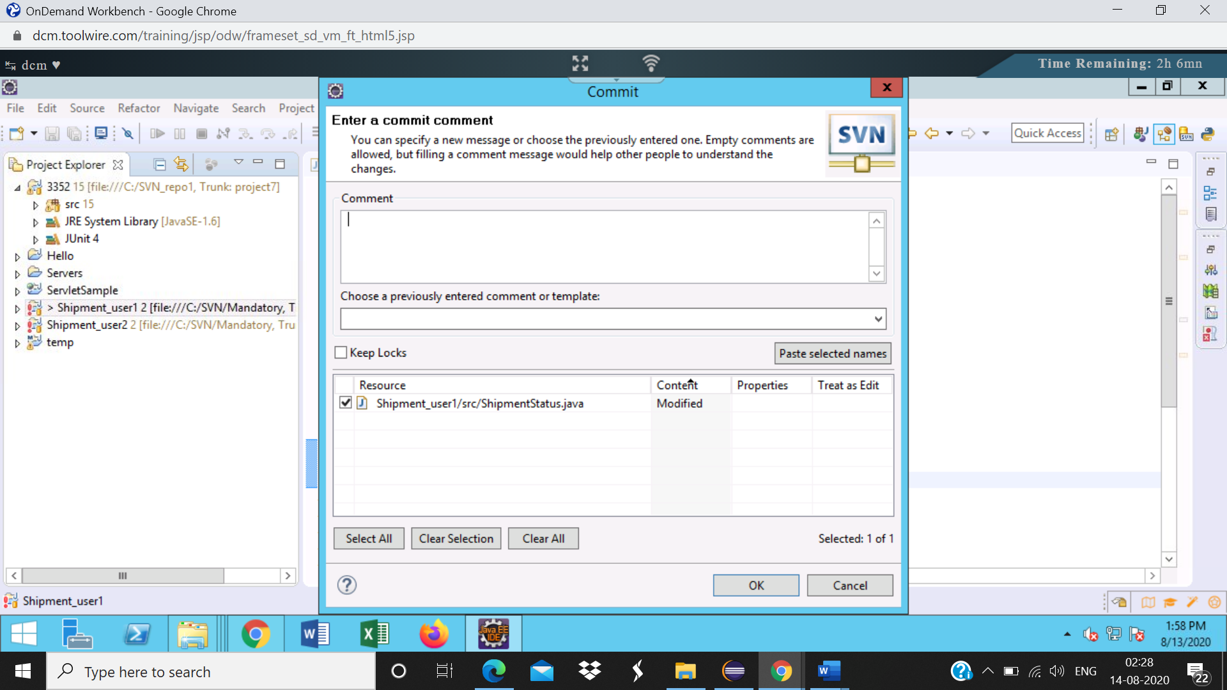

Step11:

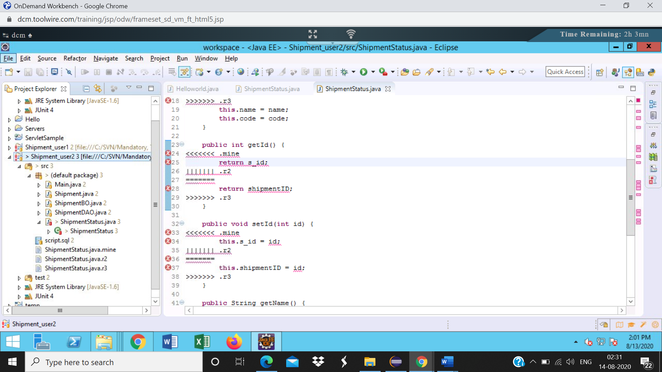

Step12:

